Exercise 5.1

1. What is normalization?
2. When is a table in 1NF?
3. When is a table in 2NF?
4. When is a table in 3NF?
5. When is a table in BCNF?
6. What is a partial dependency? With what normal form is it associated?
7. What three data anomalies are likely to be the result of data redundancy? How can such anomalies be eliminated?
8. The dependency diagram in Figure Q6.7 indicates that authors are paid royalties for each book they write for a publisher. The amount of the royalty can vary by author, by book, and by edition of the book.

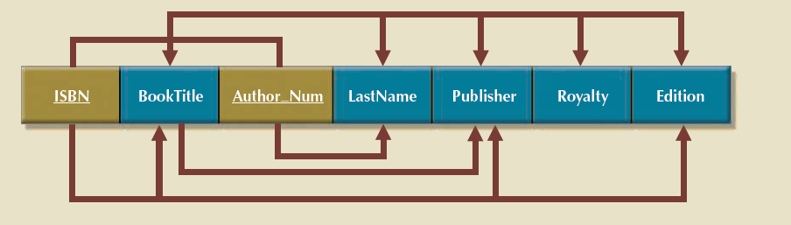

1. Based on the dependency diagram, create a database whose tables are at least in 2NF, showing the dependency diagram for each table.
2. Create a database whose tables are at least in 3NF, showing the dependency diagram for each table.